If you wish to raise a concern or complaint or need help deciding where to refer your concern or complaint contact our Resolution Lead who will look to seek a resolution or provide advice.

Netball Dorset Resolution Lead – Kelly Browne
kelly.browne74@gmail.com

Types of Complaint
- Safeguarding concern
- Competition Rules complaint
- Service provision complaint
- Code of Conduct breach

The resolution procedure for a complaint has two potential stages; informal and formal. Unless serious it is always preferable to seek to resolve a complaint through informal resolution stage at a local level.

Informal Stage
All complaints, unless of a serious nature, relating to competition rules and regulations or England Netball services, should try to be resolved informally at a local level. Please contact our Resolution Lead on the details above.

Formal Stage
If a problem cannot be resolved informally, if the issue involves allegations of serious misconduct, or the complainant wishes for the matter to be handled formally, the complaint should be handled under the formal process and the Appropriate Authority and relevant policy identified.

If a complaint is to progress to a formal stage the relevant Appropriate Authority and correct policy under which to handle the complaint

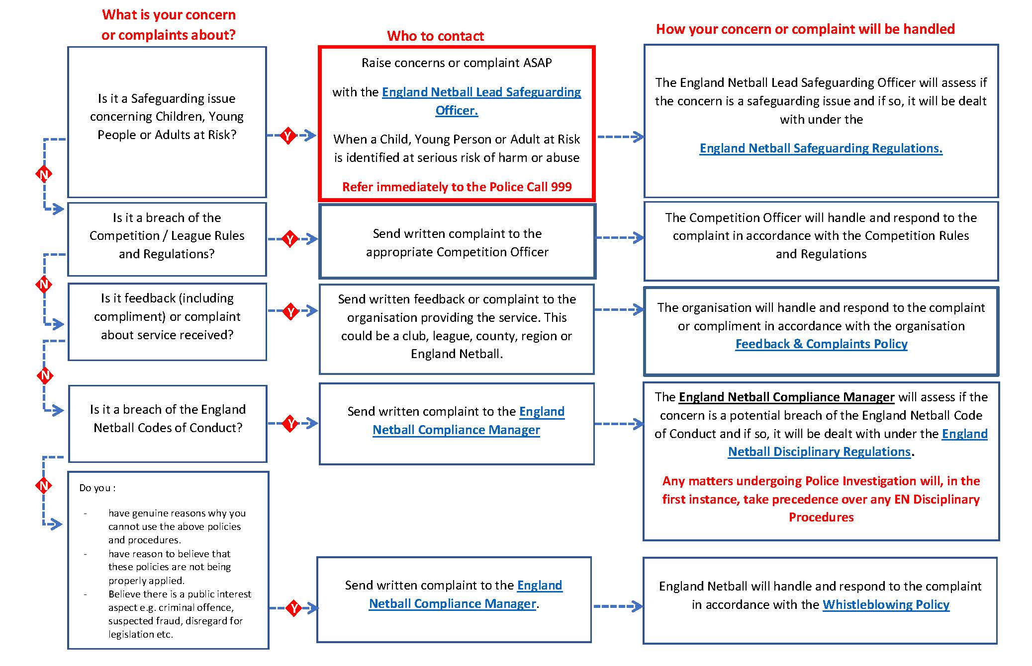

Key Contacts
England Netball | Region | County | League/Competition
Lead Safeguarding Officer  besafe@englandnetball.co.uk  01509 277911 | Region (Netball South West) Resolution Lead:  Sarah Lewis  Sarah.netball.1981@gmail.com | County (Netball Dorset) Resolution Lead:  Kelly Browne  kelly.browne74@gmail.com | Chairs contact details for Bournemouth, Poole, SWDNL and NDNL leagues can be found here:  http://netballdorset.co.uk/media/  Dorset%20Netball%20Contacts%20Aug%2021.pdf
Compliance Manager
complaints@englandnetball.co.uk
01509 277911

